* Instructions to clock in and log in to the database
  + Open the application
  + Open the database associated with the application
    - Select **File**
    - Select **Open…**
    - Choose the database **library.mdb**
  + Clock in a user to the system
    - Select **Time Clock**
      * Select **Clock In**
    - Scan or manually enter the Employee ID number of an Employee in the system
      * Note: The Employee ID entered must be an Employee within the database.
  + Log in an Employee
    - Select **File**
      * Select **Log In**
        + Select the name of an Employee currently clocked in

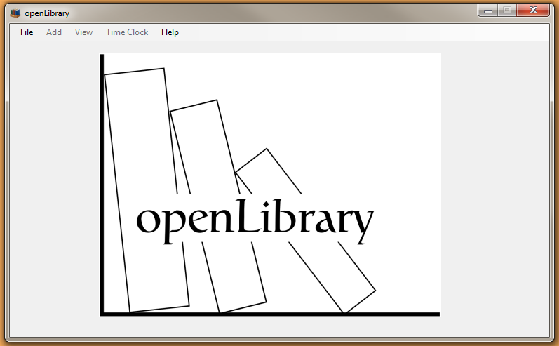 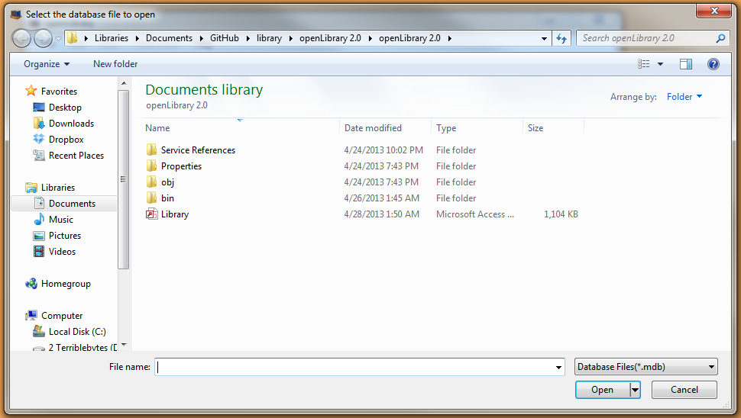

Figure 1 Figure 2

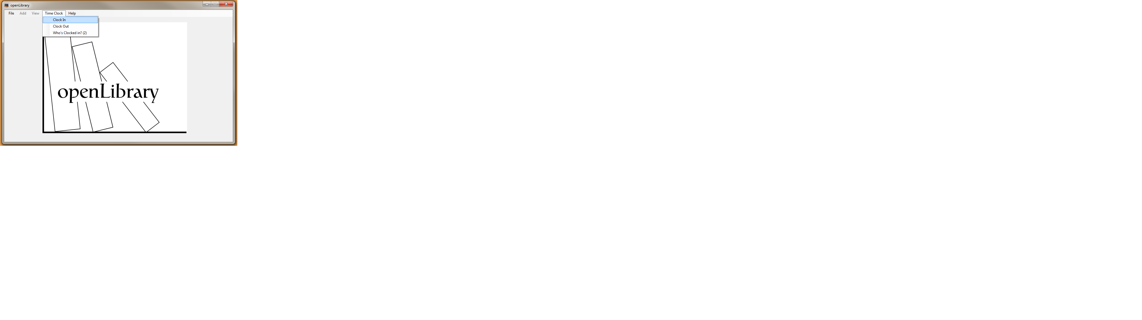 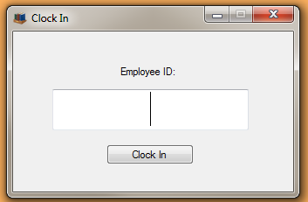

Figure 3 Figure 4

* ***“Cool Feature” # 1:*** DataGridView: Used to view the database’s data in a simple, organized manner
  + Open the application
  + Follow the instructions to clock in and log in to the database
  + Select **View**
    - Select any of the following
      * **Books**
      * **Movies**
      * **Music**
      * **Games**
      * **Customers**
      * **Employees**
  + Upon making a selection, a form will appear with the relevant data loaded into a DataGridView.
  + Close the form

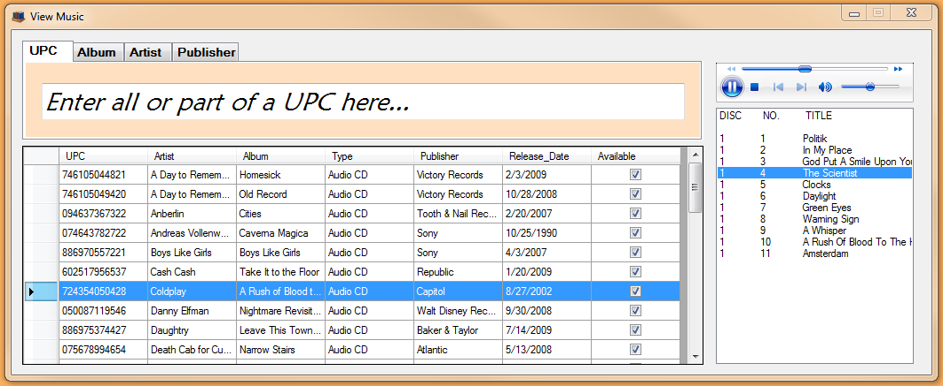

*Figure 5*

* ***“Cool Feature” # 2:*** Amazon API Lookup for books: To automatically populate fields to reduce the amount of work required of the user
  + Open the application
  + Follow the instructions to clock in and log in to the database
  + Select **Add**
    - Select **Book**
  + In the default field “IBSN”, scan or manually enter an ISBN for virtually any book
  + The rest of the fields will auto-populate using data from the Amazon database
  + Close the form
* ***“Cool Feature” # 3:*** Amazon API Lookup for Games:
  + Open the application
  + Follow the instructions to clock in and log in to the database
  + Select **Add**
    - Select **Game**
  + In the default field “UPC”, scan or manually enter a UPC code for virtually any video game (XBOX 360, PS3, Wii, Nintendo DS, PC, etc.)
  + The rest of the fields will auto-populate using data from the Amazon database
  + Close the form
* ***“Cool Feature” # 4:*** Amazon API Lookup for Movies:
  + Open the application
  + Follow the instructions to clock in and log into the database
  + Select **Add**
    - Select **Movie**
  + In the default field “UPC” scan or manually enter a UPC code for virtually any movie
  + The rest of the fields will auto-populate using data from the Amazon database
  + In addition to the fields normally populated, the main actors will also be populated into the list box on the form
  + Close the form
* ***“Cool Feature” # 5:*** Amazon API lookup for Music:
  + Open the application
  + Follow instructions to clock in and log in to the database
  + Select **Add**
    - Select **Music**
  + In the default field “UPC”, scan or manually enter a UPC code for virtually any audio CD
  + The rest of the fields will auto-populate using data from the Amazon database
  + In addition to the fields normally populated, the tracks on the audio CD will be auto-populated into the list box on the form
    - The tracks are separated by disc number and track number
  + Close the form

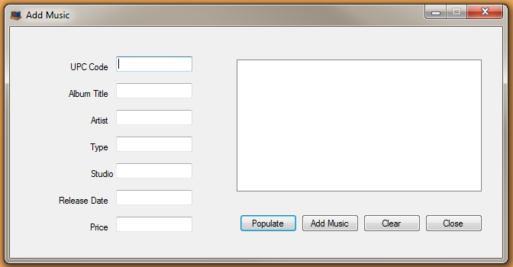

*Figure 6*

* ***“Cool Feature” # 6:*** Music Preview
  + Open the application
  + Follow instructions to clock in and log in to the database
  + Select **View**
    - Select **Music**
  + Select any audio CD from the DataGridView
  + The audio tracks on the corresponding CD will auto-populate into the listbox
  + Click any audio track within the listbox
  + An audio preview will be downloaded and begin to play
    - Choosing another audio track will stop the current track and begin a new preview
  + Close the form



*Figure 7*

* ***“Cool Feature” # 7:*** Instant Search
  + Open the application
  + Follow instructions to clock in and log in to the database
  + Select **View**
    - Select any one of the following
      * **Books**
      * **Movies**
      * **Music**
      * **Games**
  + In the search box at the top of the screen, choose a tab to search by
  + As the search query is typed, the DataGridView will automatically be updated
  + Changing the tab or otherwise leaving the search box will reset the search
  + Close the form



*Figure 8*

* ***“Cool Feature” # 8:*** Email Notifications
  + Open the application
  + Follow instructions to clock in and log in to the database
  + Select **File**
    - Select **Administrative**
      * Select **Overdue Report**
  + All overdue items within the database will be shown in the respective DataGridViews of the form.
  + Click **Send Report**
  + This will send an email to all customers with an overdue book, notifying them of the issue.
    - “Alka Harriger” is a customer in the database with an overdue book. An email has been sent.
  + Close the form

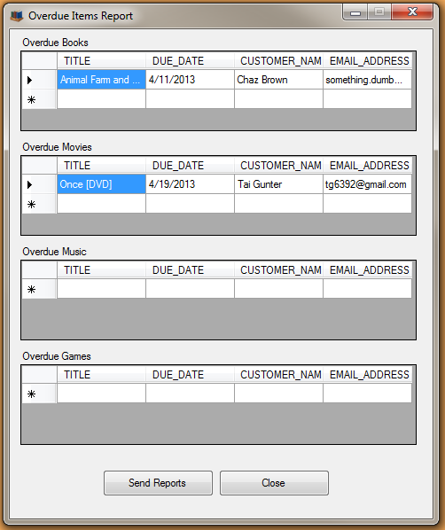 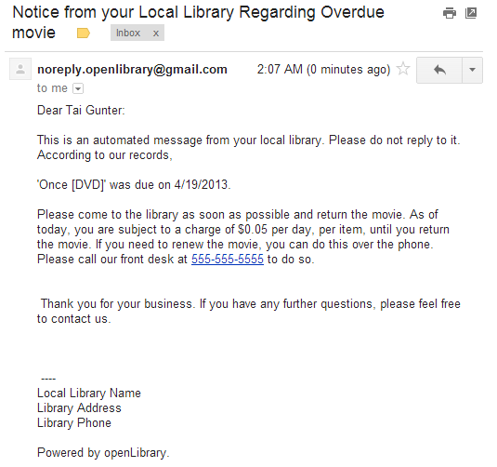

*Figure 9 Figure 10*

* ***“Cool Feature” # 9:*** Receipt Printing
  + Open the application
  + Follow instructions to clock in and log in to the database
  + Scan or manually enter a customer ID number in the text box on the form
  + Click **End Transaction**
    - When asked if you’d like to print a receipt, click **Yes.** A receipt will be printed to the default printer.
    - Note: The lack of “print preview”, “page setup” or “choose printer” dialogs is that in a true library environment, it is extremely unlikely that a user would choose a printer other than the default printer already selected, because the computer being used would most likely be a dedicated checkout/check in machine. Furthermore, print preview and page setup functionalities are unnecessary because unlike a word processing document, there (intentionally) isn’t any way for the user to edit what gets printed. A print preview option would be worthless because the user can’t change what’s being printed. Furthermore, any relevant settings in “page setup” have already been changed.
* ***“Cool Feature” # 10:*** Auto-updating login menu
  + Open the application.
  + Select **File**
    - Select **Open**
      * Choose **library.mdb**
  + Select **Time Clock**
    - Select **Clock in**
      * Scan or manually enter an Employee ID
  + Select **File**
    - Select **Log in**
      * The user that was just clocked in is now available to log in to the system.
      * If you return to the **Clock in** screen and clock in another employee, their name will show up in the log in screen.

.